Sea-Floor Spreading Name: ________________________
Unit 9 – Dynamic Crust Date: ____________ Period: ______

Lab: Sea-floor Spreading

Introduction: Sea-floor spreading is the hypothesis that the sea floor moves sideways away from the crest of a mid-ocean ridge. The two sides of the ridge are moving in opposite directions leaving a rift that is the site of submarine volcanic eruptions. Molten rock from a magma chamber 1-2 kilometers below the central rift valley and stretching along the ridge feeds up into the spreading rift. The magma fills in the crack between the separating crustal plates.
It is estimated that 20 volcanic eruptions occur each year along Earth’s mid-ocean ridges and that every year 2.5 square kilometers of new sea floor is formed by this process. With a crustal thickness of 1 or 2 kilometers, this amounts to about 4 cubic kilometers of new ocean crust formed each year.

Vocabulary:

1. Sea-floor spreading:

2. Mid-ocean ridge:

3. Seamount:

4. Rift valley:

5. Continental shelf:

Procedure A:
1. Construct a profile of the ocean bottom on the graph provided using the data chart on the back of this lab.
2. Label the following features on your profile:
Mid-Atlantic Ridge, Rift Valley, Continental Shelf, Deep Ocean Floor and Seamounts.
3. Referring to the “Tectonic Plates” map in your Reference Tables, draw arrows showing plate movement at the ridge of the Mid-Atlantic Ridge.

Distance (km) | Depth (km) | Distance (km) | Depth (km)
0 | 0 | 3500 | - 3.5
120 | - 0.2 | 3600 | - 3.7
200 | - 2.7 | 3650 | - 3.7
400 | - 3.7 | 4025 | - 4.0
490 | - 3.7 | 4050 | - 2.7
620 | - 4.6 | 4100 | + 0.5
680 | - 1.8 | 4125 | - 2.2
720 | - 4.6 | 4500 | - 4.6
2000 | - 4.6 | 5000 | - 5.0
2500 | - 4.0 | 5300 | - 4.4
2900 | - 2.7 | 5800 | - 3.7
3000 | - 1.8 | 6000 | - 2.7
3090 | - 4.0 | 6075 | - 0.2
3100 | - 2.4 | 6100 | 0
3200 | - 2.9

Procedure B:
Introduction: Using magnetic records in the ocean floor to determine the rate of Sea-Floor Spreading
Like a compass some kinds of minerals in rocks are affected by the earth’s magnetism. When a rock is heated, the mineral crystals in the rock line up in the direction of the earth’s magnetic field. When the rock cools, these crystals are frozen in the direction of the earth’s magnetic poles.
Magnetic properties of the ocean floor have made it possible for scientists to establish the age of vast areas of ocean bottom. The diagram represents a section of ocean floor in the central North Atlantic. The numbers on the lines give the ages in millions of years for parts of the ocean floor that are located along the lines.
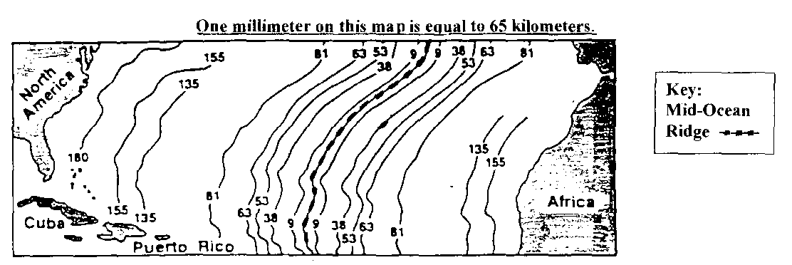

Procedure: Determine the rate of sea-floor spreading using the formula for “rate of change” in your Earth Science Reference Tables and the procedure below.
- Measure in millimeters to the left along the line from the MID OCEAN RIDGE to the date in millions of years you are measuring to.
B. Convert the distance to kilometers by multiplying the value times 65 (based on the map scale) C. Convert the distance to centimeters by multiplying the value you determined in kilometers by
100,000.
D. Calculate the rate of sea-floor motion using the following equation:

Rate of sea-floor motion = Actual distance ocean floor moved (cm) - column #6
Time to move that distance (millions of yrs.) - column #1

#1 | #2 | #3 | #4 | #5 | #6 | #7
Line Age (Millions of Yrs.) | Shortest Distance (mm) | Convert | Shortest distance (km) | Convert | Shortest distance (cm) | Rate of Seafloor Motion (cm/yr)
9,000,000 |  | X 65 |  | X 100,000
38,000,000 |  | X 65 |  | X 100,000
53,000,000 |  | X 65 |  | X 100,000
63,000,000 |  | X 65 |  | X 100,000
81,000,000 |  | X 65 |  | X 100,000
135,000,000 |  | X 65 |  | X 100,000
155,000,000 |  | X 65 |  | X 100,000
180,000,000 |  | X 65 |  | X 100,000

The rate of sea-floor motion is a measure of how fast the ocean floor is moving away from the Mid-Ocean Ridge. Determine an average rate of sea-floor motion using your calculations in column #7.

AVERAGE RATE OF MOTION = __________________________________

The rate of sea-floor spreading is a measure of how fast sections of ocean floor on opposite sides of the Mid-Atlantic Ridge are moving away from each other and can he found by doubling your average rate of motion.

AVERAGE RATE OF SEA-FLOOR SPREAD1NG = _________________________________________

Discussion Questions (ANSWER IN COMPLETE SENTENCES)
Base your answers to questions 1 - 2 on Procedure A and your profile.
1. What prominent sea floor feature is found in the central Atlantic Ocean?

__________________________________________________________________________________________

2. How did the rift valley form? What is the name of this type of plate boundary?

__________________________________________________________________________________________

__________________________________________________________________________________________

Base your answers to questions 3 - 5 on procedure B.
3. What do the mineral crystals in seafloor rocks say about the positions of the earth’s magnetic poles?

__________________________________________________________________________________________

__________________________________________________________________________________________

4. As the distance from the Mid-Atlantic Ridge increases, what change in the age of the seafloor is observed?

__________________________________________________________________________________________

__________________________________________________________________________________________
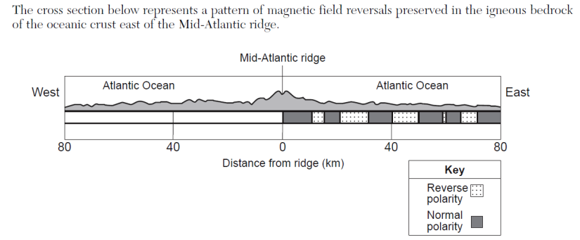
5.

